Part 2 Interim Report

# 2. Literature Review

## 2.1. Introduction

In this chapter, research into areas related to nutrition and dietary needs is the priority. These areas include the different industry solutions, different types of technology applicable to domain area, other useful strategies or research relating to the project aim and studying technical solutions provided by other college students relating to the domain of interest. How the potential solution would be applicable to the target user would also be explored here too.

## 2.2. Alternative Existing Solutions to Your Problem

Two alternative solutions researched into were “Fitbit” and “mySugr”. Both were found on the “Play Store” for the Android devices and so are mobile applications. When assessing the applications, a comparison between the goal of the team behind the application and the app’s functionality was conducted combined with evaluation of the “UX”, “Design” and “Ease of use” for overall critical review.

**Fitbit**

According to Play Store Application specification, Fitbit “is dedicated to helping people lead healthier, more active lives”. The application main functionality is logging key information, such as the diet, water intake, exercise tracking and a weight goal. Through all these activities, Fitbit assists the user in monitoring the physical condition for overall improved health, which incorporates sleep, eat, exercise and repeat. Fitbit also monitors the heart rate through syncing with multiple external devices, such as Fitbit watch, designed to track such details.

The overall design of the mobile application is clean and smooth. However, it is not easy to use. Parts of the design interface do not follow conventional operational standards in its attempt to be unique, such as clicking on the user profile picture to access the navigational tool. Another aspect is the logging of the data, designed as part of feature usage specification. Because in-depth knowledge of the input such as calories is part of the requirements, the standard of ease of use would be reduced heavily.

This would make the user experience moderate to a disappointment for the average user, as most would not have the knowledge at their depth. The application is catered to specialists or team for an athlete as the typical user.

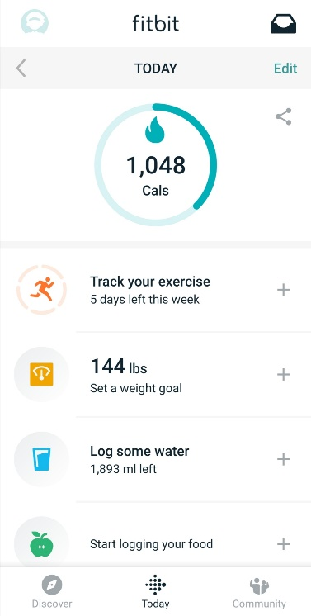 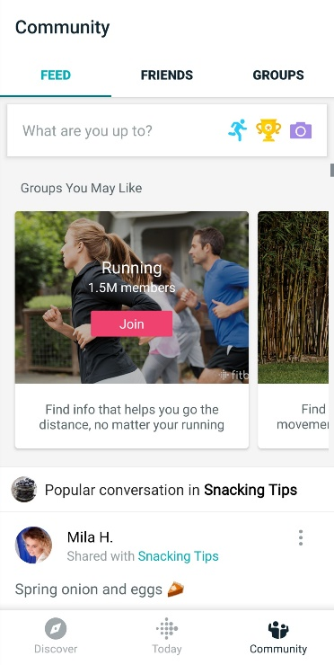

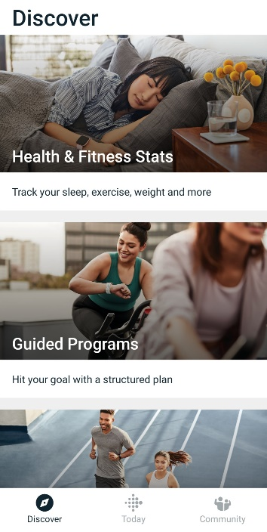 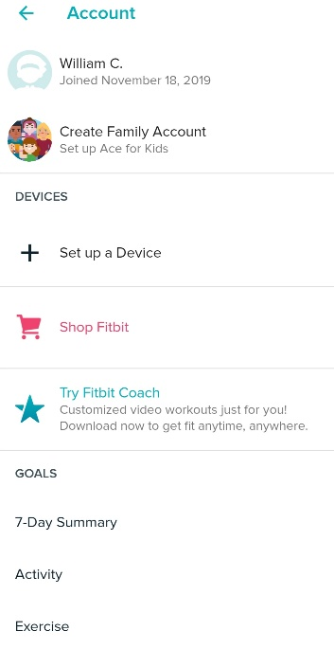

**mySugr**

An app “to manage your diabetes and HbA1c”. It was ranked “the top diabetes app by Healthline 3 times”. The functionalities of the application are access to easy and personalised dashboard (including diets, meds, carb intake, meals, blood, glucose etc), clear blood sugar level graphs, estimate HbA1c, motivating challenges and feedback, medical analysis (daily, weekly and monthly), detailed reports for the doctor and secure data backup, which incorporates regulatory compliance, quality and safety for the user.

The design of the application is simple yet smooth and intuitive. The graphical element grabs the user attention to return and keep using the application, while at the same time using familiar toolkits and standards for minimal learning curve. The ease of use is at medium level, as the complex area of the application is the logging of diabetes. This requires abundant knowledge and insight into the diabetes domain. Otherwise it is simply enough for anyone necessarily needing it.

The overall UX for the application is only a level higher than the expected standard. From a design and ease of use, the UX is pleasant for anyone to use. The complexity area, which is the logging aspect of the application, is the only critic area of the UX and area to improve on.

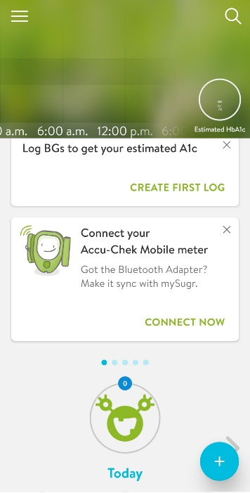 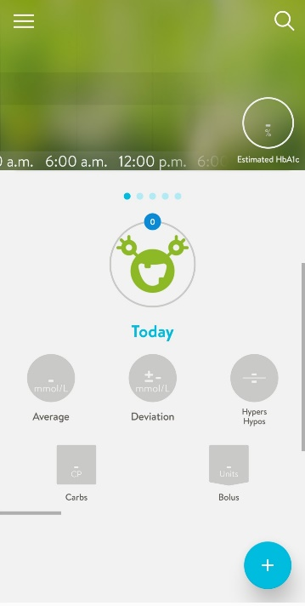 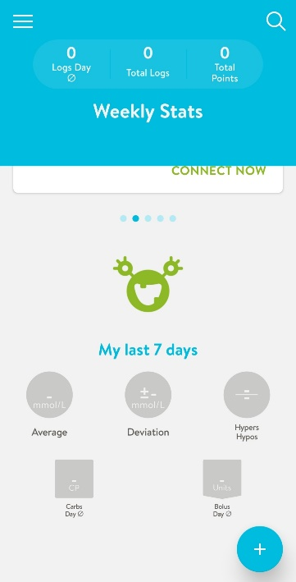

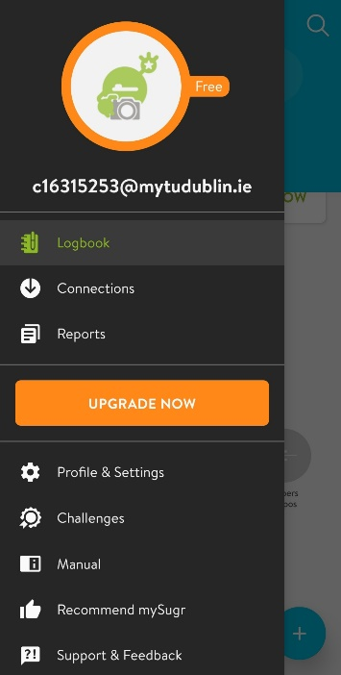 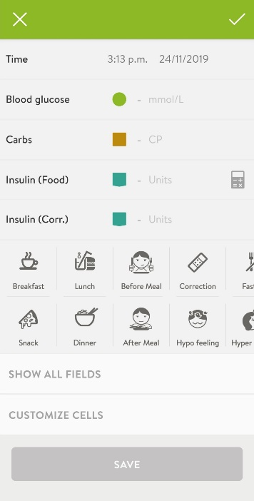 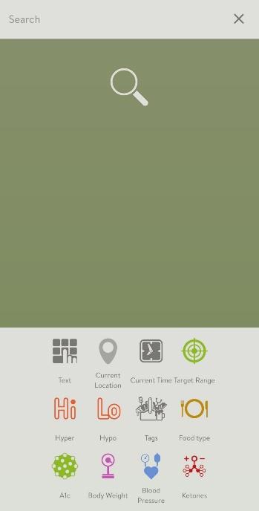

**Overall Evaluation of Industry Mobile Applications**

The areas to be covered for overall evaluation are UX, functionality, design and ease of use. Regarding mobile applications in the nutritional fields the evaluation varies. The functionality requirements for the application, such as fitness or nutritional deficiencies, have been met for the user.

The design varies. In some applications, conventional standards are followed, which minimises learnability simultaneously with maximising usability. However, the learning curve are not low for someone who never used apps like it before, which may put off non-technical proficient users.

Ease of use, regarding the core aspect of the applications, are moderate to low. This is due to the necessary in-depth knowledge of the area the app was designed for, such as logging nutritional data, which is the heart of the application. These specifications are not something ordinary people would have at hand, which would hinder the overall user experience. All other design decisions are either easily learnable or expected to be known beforehand.

The UX overall, because of the dependency of the logging of the data, is moderate and requires patience as specific measurements are needed for the app optimising.

**Conclusion**

The application functionality and design are universally catered towards specific user group. They do not expand the UX to generic users. As a result, the focus of the application for the project should be the UI design to allow for generic input rather than specific. This would improve the UX and ease of use combined with giving a feature to make the application stand out.#

## 2.3. Technologies you’ve researched

**Mobile Technologies and their integrated development environment**

There were a variety of mobile technologies that were investigated for the purpose of the project. As each were delved into, the questions of how they would fit the requirements all the requirements of the application were the main priority. These were the technical requirements, the businesses requirements and the user requirements simultaneously. By research into the popular hybrid mobile applications by the developing community, an outline of the four most popular technologies, PhoneGap IDE, Ionic, React Native and Xamarin, will be employed.

**PhoneGap**

By wording of Orion Info Solutions Website, “PhoneGap is open source freely available app which can be run on different platforms. There is rapid increase in these types of apps as they are easy to maintain and save both time and money.” Because applications created using PhoneGap are developed using modern web technologies (HTML5, CSS3, JS libraries), they provide “easy testing and maintenance” to the community and allow for usage without learning any “additional skills”. They also support “multiple platforms such as Android, iOS, Window” through providing software that are “easy to access”.

Objectively, downsides are part of the application. Due to knowledge “PhoneGap Apps are very poor in performance, they are not recommended for the gaming technologies as compared to native apps”. They also fail “in providing the access and control to the user” due to their “slow processing”. The same apps “become inefficient” when working with the same “native apps”. As a result of such design decisions, the layout of PhoneGap apps are not “as good as native apps”.

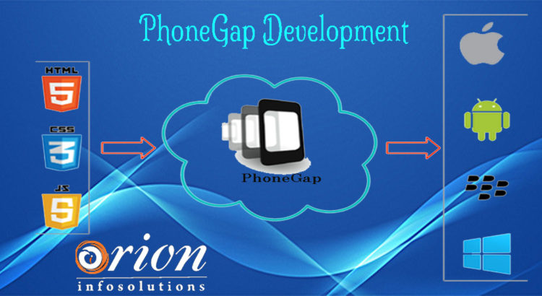

**Ionic**

Through insight of the Altexsoft Website, [Ionic](https://ionicframework.com/) was created “2013 as an open-source SDK for hybrid mobile applications” and “now has more than [5 million apps](https://ionicframework.com/community) built using it”. The reasoning behind the numbers is the “strong [growing] community” and the “Concise documentation” built with the application. An area where its best known for is “providing platform-specific UI elements … for iOS and Android”, which allows for “quick prototyping”.

Some areas of weakness for Ionic starts with “Absence of hot reloading”, a feature which allows developers to make a change to the system which changes the layout in real time. This combined with the design of being a “Plugin-dependent system” makes any application designed by Ionic have potential “security issues”. The final issue, which had a significant part in the decision making, is the “performance is lacking [when compared] with native applications”.

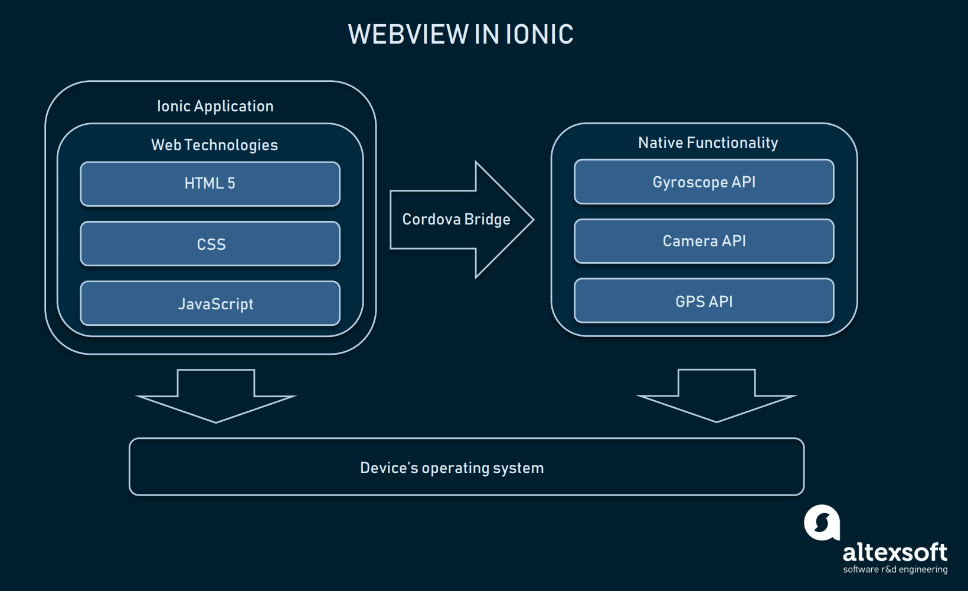

**React Native**

The Altexsoft Website states React Native is “a hybrid mobile-app development framework for iOS and Android.” Built using the tools of ReactJS, “a JavaScript library that [uses] the speed of JavaScript” to make applications “highly dynamic and responsive to user input “, React Native combines native application development with JavaScript UI development. React Native has been created by Facebook and is open source for growth of community developers. The speed of the development comes from the usage of the “Virtual DOM in ReactJS”. This ensures both” user experience” and “developer’s work” are improved simultaneously.

Cons of the application are as follows, the tighting of coupling of business logic is an issue when system’s design find “HTML in [the] JavaScript”, making it difficult for decoupling. When comparing the “High pace of development” vs the pace of updating “Documentation”, it is found to be a major disappointment as it is not completed concurrently. Thus, it is not surprising the last major issue is the “Lagging SDK Updates”.

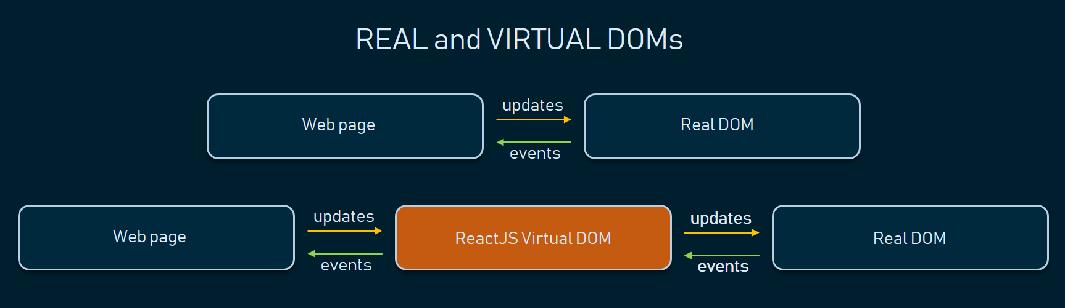

**Xamarin**

The last tool being covered today, also evaluated by the Altexsoft Website, is Xamarin. “Xamarin is a tool used for cross-platform mobile app development that allows engineers to share about 90 percent of code across major platforms”. “It is based on the Microsoft technology stack and already has a community of over 1.4 million developers”. Being “Open Source Technology with Strong Corporate Support” gives Xamarin a competitive advantage when compared with some of the other IDEs, such as receiving “Full Hardware Support” from the developing community and private institutions, which grants “Simplified Maintenance”. Such efforts ensure applications developed from Xamarin are provided “Performance Close to Native” applications developed.

Imperfections and Drawbacks from Xamarin can be drawn. Due to the corporate support, there is a “High Cost [of development] for Professional and Enterprise Use” and a strict guideline of the required language needed. Applications derived from Xamarin ide usually are a “Larger App Size”. These drawbacks result in “Basic Knowledge of Native Languages” are required to build such applications combining with “Compatibility Issues with Third-Party Libraries and Tools”, due to mistrust of larger cooperation’s from the potential of hackers.

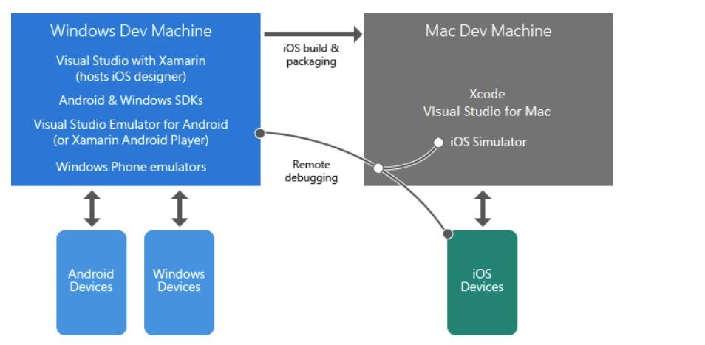

**Middleware technology**

Described by Techopedia website, “The .NET framework is a software development framework from Microsoft. It provides a controlled programming environment where software can be developed, installed and executed on Windows-based operating systems”.

The main design principles behind the framework are Interoperability (allows programs functionalities to be accessed outside .NET), Common Runtime Engine, Language Independence, Base Class Library, Ease of Deployment (ensure the ease of installing programs without interfering with previously installed applications) and Security. Because of these features, .Net framework has been employed on many applications to allow separation of concerns between the different areas of the applications. These include front-end to backend communication.

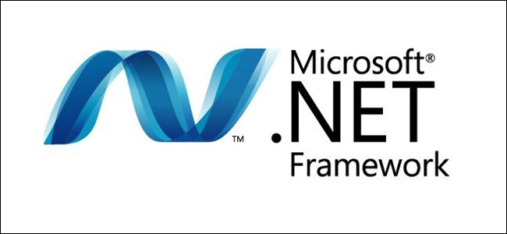

**Cloud services**

All cloud services provide solutions including **Infrastructure as a Service** (IaaS), **Platform as a Service** (PaaS), and **Software as a Service** (SaaS) that can be used for services such as analytics, virtual computing, storage, networking etc. Such services allow for remote connections from any where in the world, as one main aspect of cloud is it resides on the world wide web. The three competitive public examples in the present moment are Azure Microsoft Cloud services, Amazon Web Services (AWS) and Google Cloud Platform Services. All three would provide the same role for both remote services and storage purposes. The only significant difference between each is the producer of the servicers, with Microsoft hosting Azure, Google with its own and Amazon with its web services.

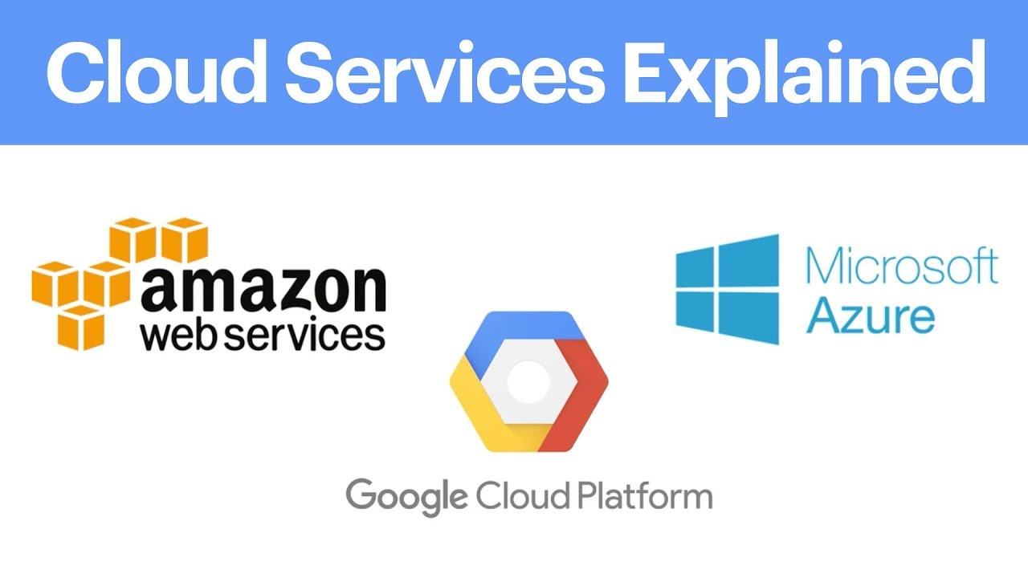

**Backend Database technology**

All the cloud services offer SQL relational database and servers for remote storage, which will be taken with delight and used. For local storage, SQLLite will be used as it is most convenient for mobile application development for minor purposes. The bulk of storage will be completed by the remote storage.

**Operating Systems**

**Android**

According to lifeWire, “Android is a popular, [Linux](https://www.lifewire.com/beginners-guide-to-linux-4090233)-based mobile phone operating system developed by Google”. It is an open source project which Google provides to various device manufacturers for free. From Huawei to Samsung, Android is used in each device development and is maintained to adhere to the different specifications. This would allow for diverse use of the phone, providing different phone user experiences. However, as a result is very difficult to keep updated against the different risks against the devices.

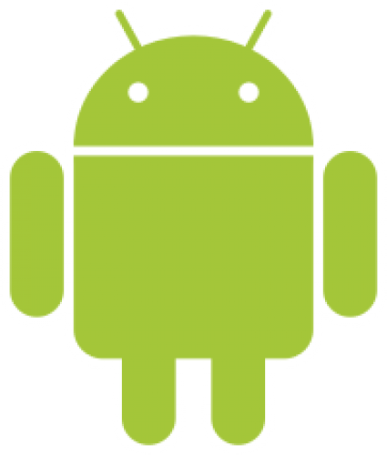

**iOS**

Recombu states “iOS is the mobile operating system that runs on Apple’s mobile devices, i.e. [iPhones](https://recombu.com/mobile/article/apple-iphone-6s-review) and [iPads](https://recombu.com/mobile/article/apple-ipad-air-2-review). It’s the main software that allows you to interact with your Apple phone or tablet”. While Android is versatile with the devices employed, iOS is restricted to apple products and apple software only. This makes the design more maintainable due to the company able to design the two together simultaneously while making the application safer, when compared to Android, by preventing downloads from Third-libraries sources.

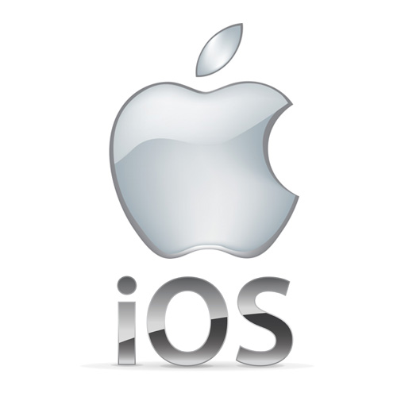

**Programming Languages**

**C#**

When reviewing “Geeks for Geeks Website”, information found about C# are describing the language as “a general-purpose, modern and object-oriented programming language”. The language was developed by a Microsoft team within the .NET initiative. This team led by Anders Hejlsberg. The language was approved by the European Computer Manufacturers Association (ECMA) and International Standards Organization (ISO). C# is similar to [Java](https://www.geeksforgeeks.org/java/) syntactically and easy for users who have knowledge of [C](https://www.geeksforgeeks.org/c-programming-language/), [C++](https://www.geeksforgeeks.org/c-plus-plus/) or [Java](https://www.geeksforgeeks.org/java/).

**Scripting Languages**

**Python**

Another language reviewed under “Geeks for Geeks”, [Python](https://www.geeksforgeeks.org/python-programming-language/) is a widely used general-purpose, high level programming language. It was initially designed by Guido van Rossum in 1991 and developed by Python Software Foundation. It was mainly developed for emphasis on code readability, and its syntax allows programmers to express concepts in fewer lines of code.

**Other Software and Tools**

**GitHub**

GitHub is a git repository hosting service and version control system. By managing different git repositories, it can manage different versions files and systems through individual or collaboratively efforts. The main features are to allow users to push, pull and merge different applications versions, making it a powerful tool in managing any type of projects developed in iterative steps.



## 2.4. Other Research you’ve done

**Usability**

Usability Theory is the concept on human interaction with technology through the means of “effectiveness, efficiency, and satisfaction”. This should ensure the system is “easy to learn and remember, efficient, visually pleasing and fun to use; and quick to recover from errors”. From the same studies it is shown how people remember usage of systems combined with processing certain images.

**Assistive Technology**

Assistive Technology is the use of technology to assist people with certain disabilities. These would include vision issues, such as the blind, and providing them with appropriate solution, such as text-to-speech. Another example would be those with mobility issues and providing them with similar solutions like voice recognition.

**Nielsen’s Heuristics**

An evaluation method for systems that have heavy usage on interfaces. While on the older side, the 10 evaluation methods are still applicable for modern applications containing heavy GUI elements usage. Such approach will be kept in mind for evaluation of similar technologies and the development of the application.

**Modern Mobile usability**

As mobile applications availability increases to the people, the application’s requirements need to cater to ensure the user is engaged correctly. This is through ensuring the user can complete their tasks in the expected optimal time by providing the following six methods from the source website: Platform Usability, Provide Value Right Away, Simple Navigation, Clear & Concise Content, Minimize the Number of Steps and Reduce Scrolling methodologies.

## 2.5. Existing Final Year Projects

**Project 1**

**Title:** Proactive Order Management System

**Student:** Stephen Fox

**Description (brief):**

An application that allowed businesses to handle orders processes by analysing its data within the system. This system also provides businesses with information on how and when to process these orders. The order processes are placed into the system remotely through customers using a mobile application that can access and connect to the host web system.

**What was complex about this project?**

The task Scheduler manager was the most complex part of the system as many uncertain fields that could change that this system needed to calculate in order to be optimised for the overall system.

**What technical architecture was used?**

A Client – Server application with the tech tools iOS Application, Web Application and AngularJS acting as the client-side while Node.js, NuPIC, Proactive Module - Flask, Google Map Distance Matrix API and MongoDB as the server side

**Explain the key strengths and weakness as you see it**

To have an algorithm that dynamically creates task handlers based off the tasks requirements is a strength as it allows you to expand your resources and minimise data wastage at the same time.

The data involved does not seem to be protected through encryption or other methods, which could allow nearby people who could steal the data to view the data, is a major weakness of the application.

**Project 2**

**Title:** Glucose Coach

**Student:** Alex Kiernan

**Description (brief):**

An application designed to track people whom have type 1 diabetes to better manage their overall health by logging their blood sugar levels, their diet and their physical exertion into the coaching system. Once logged, the application will be able to provide the necessary suggestions catered to the individual user to enable them to better manage their glucose levels.

**What is complex about this project?**

The machine learning part of the overall system was the main complexity as research was needed to be conducted combined with the development of the sound process in order to properly process the user information into the system and export back accurate results to the user.

**What technical Architecture was used?**

A Client – Server architecture was used with the RESTful service links between the two, a remote relational database, a flask server and the machine learning system scikit-learn as server side while the use of a mobile application as the client.

**Explain the key strengths and weaknesses as you see it**

A key strength of the application was at the time of development, the constant monitoring of the users progress with the insulin intake was unique to the system design which provides it a competitive edge compared with similar applications

A weakness of the application would be the lack of knowledge provided back to the users whom used this application. If there were graphs that displayed over time the use of insulin intake over days and weeks, it would have made the user understand their blood sugars levels more in depth, which would have allowed them to make more informed decisions.

## 2.6. Conclusions

The main requirements for the use of the application are designed for the ease of use, the user experience and key polished functionality of the application. As a result of these requirements, along with the user requirements and business requirements, the technologies chosen were using Xamarin for the front-end, the .Net framework for the middleware, Azure Cloud services with for remote service and SQLite for local storage.

These technologies are best suited for the development of the application through their adaptability to the users’ requirements, the developers technical needs and the General User Interface requirements.